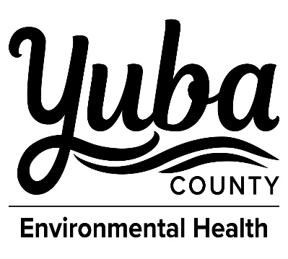
YUBA COUNTY CDSA
915 8th STREET, SUITE 123 MARYSVILLE, CA 95901
(530) 749-5450 FAX (530) 749-5454

WATER QUALITY MONITORING REQUIREMENTS
TRANSIENT, NON-COMMUNITY WATER SYSTEM

Constituent | Frequency
Coliform | At least one sample per quarter shall be collected in accordance with an approved Bacteriological Sample Siting Plan. TNCs must sample monthly during any month in which 1,000 or more persons are served. Systems that disinfect (i.e., chlorinate) shall also collect one sample per quarter at each source. Chlorine residuals must be collected with all coliform samples.

Constituent | Groundwater Source | Standby Source*
Primary – Inorganics  Aluminum  Antimony  Arsenic  Barium  Beryllium  Cadmium  Chromium  Fluoride  Mercury  Nickel  Selenium  Thallium | Once | Once
Secondary Standards  Bicarbonate, Carbonate & Hydroxide Alkalinity Calcium  Iron  Magnesium  Manganese  pH  Specific Conductance Sodium  Total Hardness | Once | Once
Nitrates | Every year | Every 9 years
Nitrites | Every 3 years | Every 9 years
Nitrate + Nitrite | Every 3 years | Every 9 years
*The California Code of Regulations (Title 22, Chapter 15, Section 64414) requires that a standby source only be used for short-term emergencies of five consecutive days or less, and for less than a total of fifteen calendar days per year.

A state certified laboratory must perform the analyses and, with the exception of lead and copper monitoring, collect the samples for chemical analyses.

